You have been hired by the management of European Retail Chain to analyse the data and present it to the management.

The supplied dataset is in AmazingMart-EU.xlsx format.

Your task is to create the following charts:

1. Show Region, Country, City wise Sales using maps

2. Show month over month sales with ability to select the subcategory

3. Show sales and profit for subcategory using appropriate visualization

4. Show average days to ship for each shipping mode

5. Show region wise sales for categories with ability to select categories

6. Show top 5 profitable countries and bottom 3 least profitable countries in one sheet

7. Show category wise, sub-category wise quantity sold

8. Show the relation between profit and sales per customer.

9. Show top 10 cities with lowest Average of days to ship in economy mode

10. Show country wise count of orders on map

Landing Page

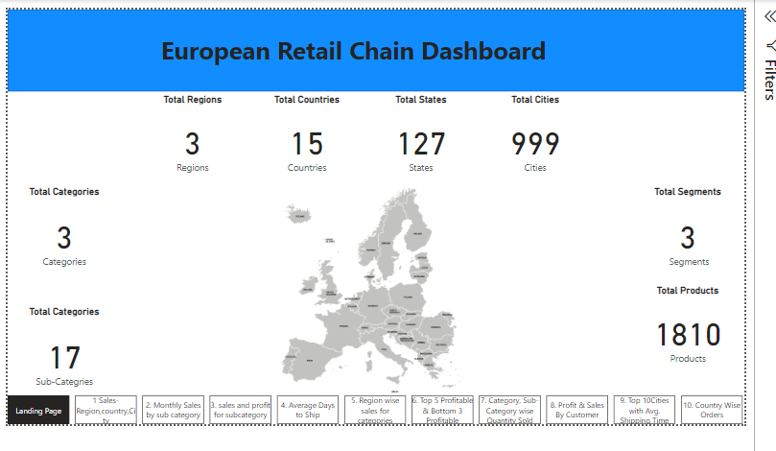

Q1

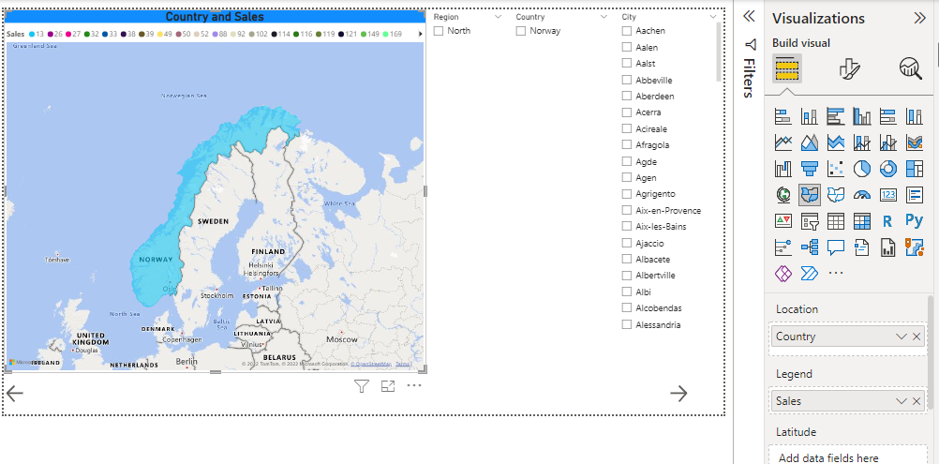

Q2

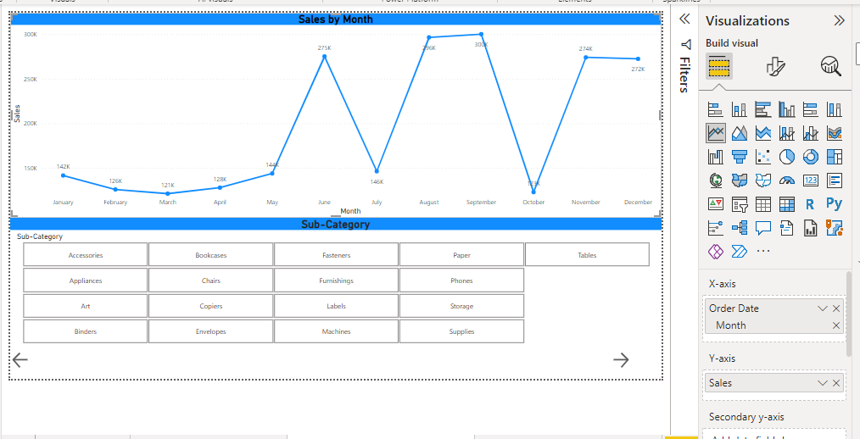

Q3

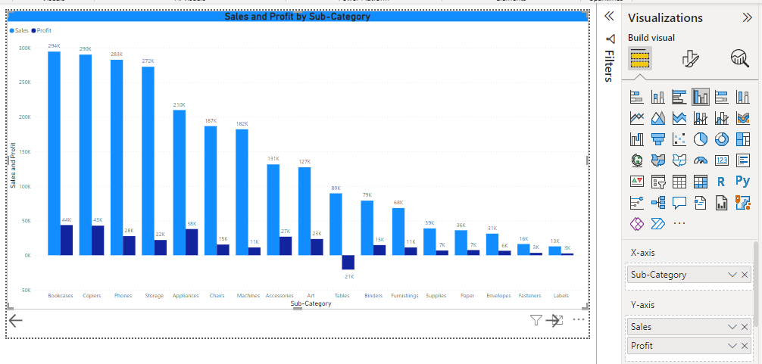

Q4

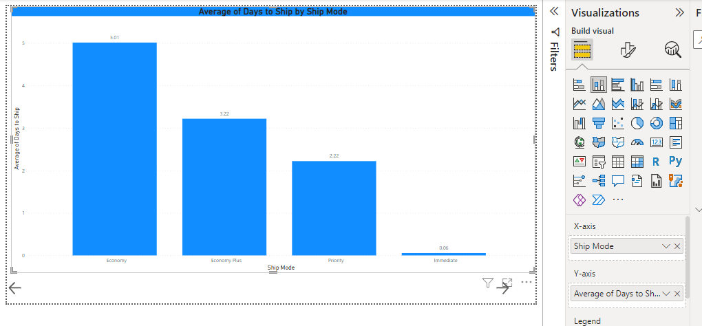

Q5

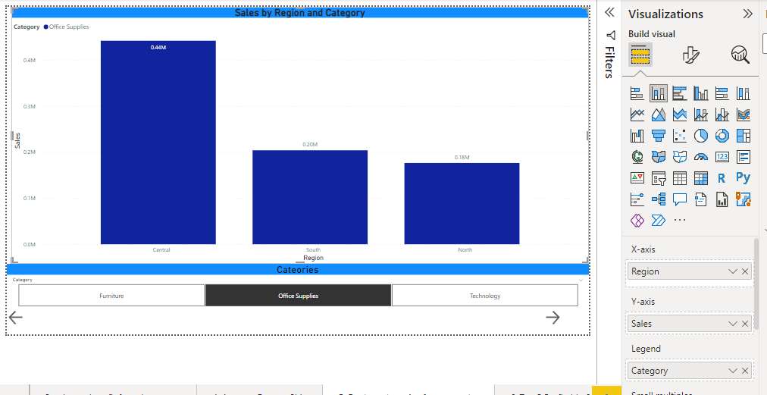

Q6

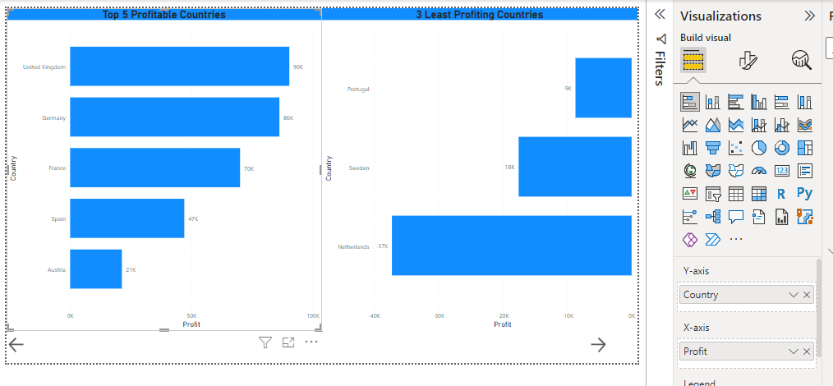

Q7

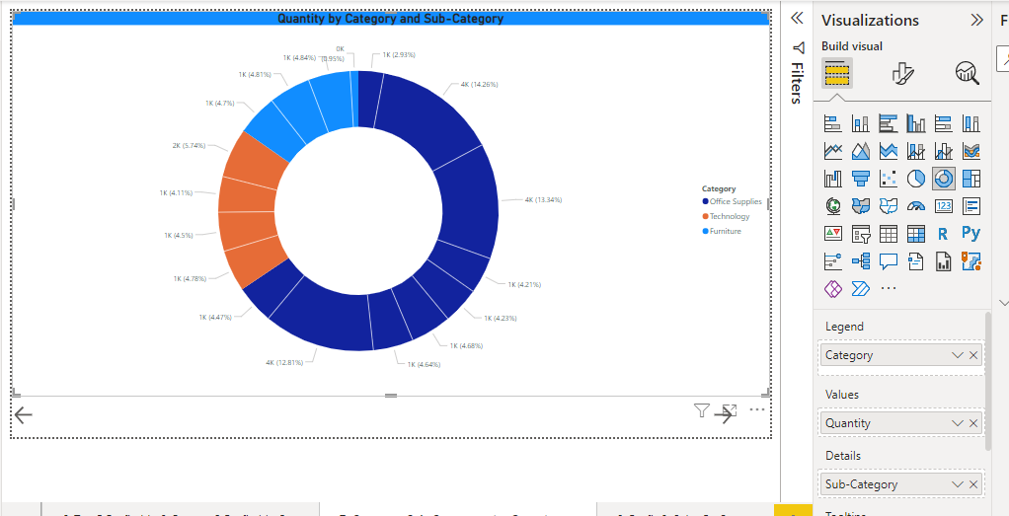

Q8

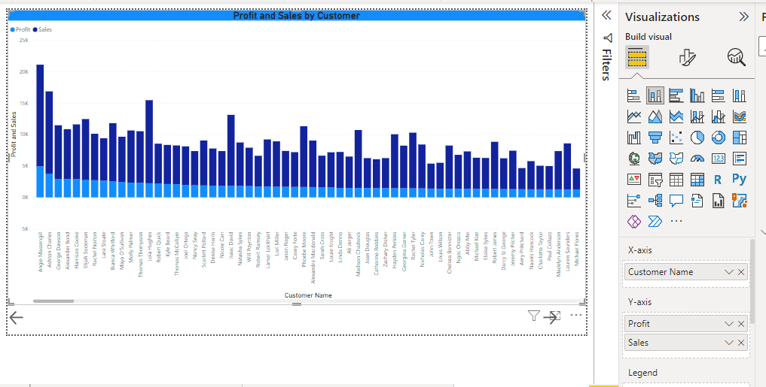

Q9

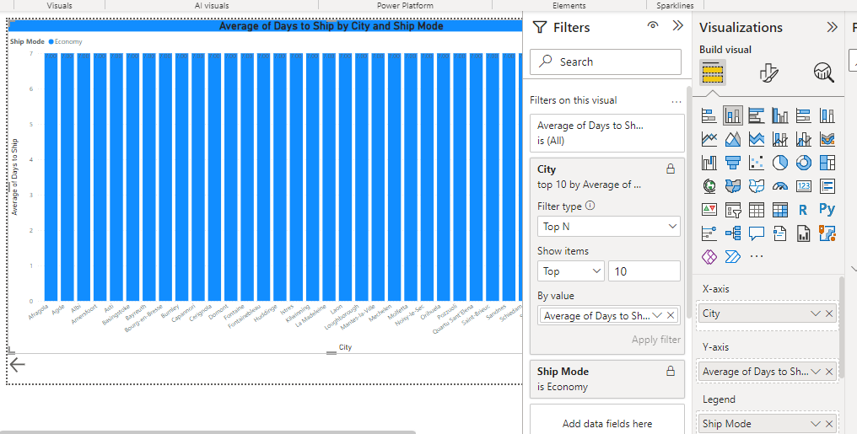

Q10

